Busy Bee’s Curriculum:
Spring and Developing our Fine-motor skills through play and exploration.
Curriculum Goals
These goals have been determined through observation and collaboration of practitioner’s opinions. We wanted to support, strengthen and develop children’s fine motor skills for early preparation for children starting school in September. We also want to incorporate Spring to enhance children’s knowledge of the changes in our environment. We are also celebrating upcoming celebrations like Eid and Easter.
- Focusing on Fine Motor Skills- Being able to use one handed tools and equipment with purpose and strength.
- Focusing on Spring- exploring the natural world and changes of the season as the warmer weather approaches.
- Building confidence- Being able to use scissors, cutting tools, knifes, threading, tweezers etc.
Our Assessment Framework is observational, child-centred and formative. Focusing on fine motor skills and environmental observations of Springtime.

Upcoming Celebrations:

Ramadan begins: 28th February 2025
Shrove Tuesday: 4th March 2025
Eid: 30th March 2025
Mother’s Day: 30th March 2025
Good Friday: 18th April 2025
Easter Sunday: 20th April 2025
Easter Monday: 21st April 2025

Communication and Language:  -Daisy’s giant sunflower story book.  -Talking about the environment and changing seasons.  - Nursery rhymes singing at group time.  -Introducing new words, e.g. Budding, Blossom, Pollination etc. | Personal, Social and Emotional Development  -Nature walks with our friends  -Nature sharing circle- sharing our thoughts on seasons/plants etc  -Recognising different emotions and how our natural world can make us feel. | Physical Development  -Play dough- dough disco, using tools and equipment  -Pencils, drawing and stencil drawing  -Collage making with recycled objects  -Planting seeds,  -Mother’s Day cards/ crafts  -Making bird feeders  -Easter egg and spoon race  -Obstacle courses  -Scissor control cutting sheets |  | Literacy  -Creating chicks, bunnies for Easter celebrations  -Daisy’s giant Sunflower group time story.  -Pencil control worksheets  -Finger painting  -Dot to dot activities  -Bead threading
Springtime and Developing our Fine Motor Skills through play and exploration
WC 24/2/2025
Mathematics  -Fingerprint counting  -Counting flowers in the outdoor area  -Number rhymes during group time- sleeping bunnies, 5 Speckled frogs  -Colour matching bears/dinosaurs  -Measuring growth of flowers |  |  |  | 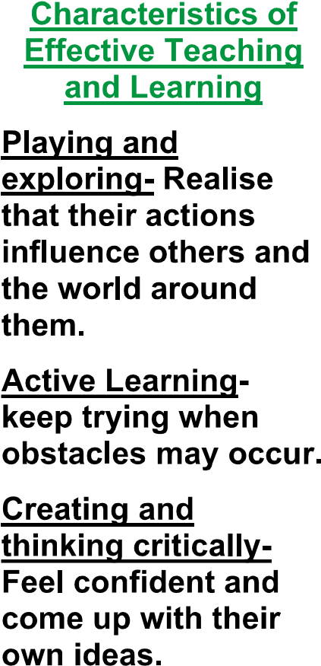
 | Understanding the World  -Mother’s Day crafts  -Eid painting/colouring  -Pancake tasting for Shrove Tuesday  -Springtime planting  Planting cress  -Fruit kebabs- trying new fruits |  | Expressive Arts and Design  -Easter egg decorating  -Easter Bonnet competition  - Sensory tuff tray with different natural resources from the garden  -Scented playdough  -Easter biscuits- decorating to take home  -Free painting- using different one-handed tools,  -Dough Disco
Circle time | Scavenger Hunt | Create a fairy garden | Make your own Kite | Den Building | Looking at our shadow
Hopscotch | Tuff tray exploring | Chalk Painting | Bird Feeders | Bark printing | Bean Bag throwing
Planting seeds | Springtime story Daisys Giant Sunflower | Mud Kitchen | Nature Hunt | Water painting | Measuring
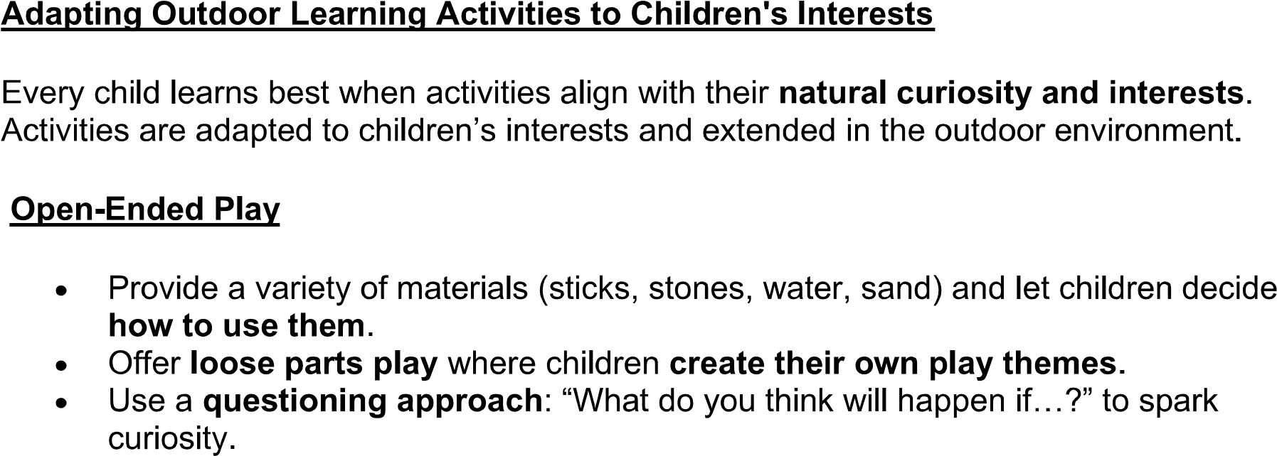
Outdoor Learning Curriculum for Spring Term:

